**Step 1**: Use maven to create web app

mvn archetype:generate -DgroupId={project-packaging} -DartifactId={project-name} -DarchetypeArtifactId=maven-archetype-webapp -DinteractiveMode=false

**Step2**: Import this project in eclipse

Above two step can be done in eclipse by creating maven project

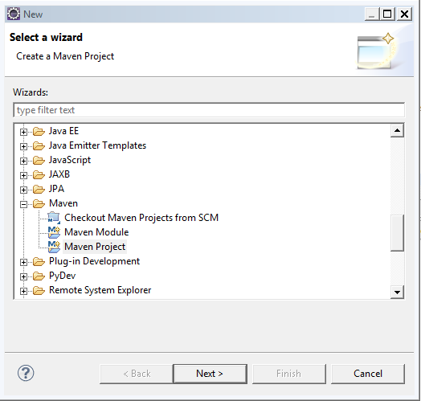

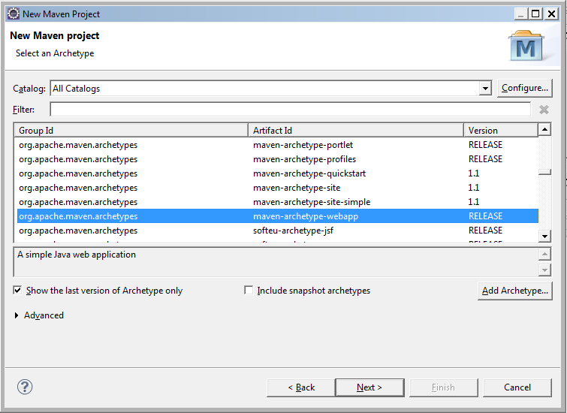

Pom file:

<project xmlns=*"http://maven.apache.org/POM/4.0.0"* xmlns:xsi=*"http://www.w3.org/2001/XMLSchema-instance"*

xsi:schemaLocation=*"http://maven.apache.org/POM/4.0.0 http://maven.apache.org/maven-v4_0_0.xsd"*>

<modelVersion>4.0.0</modelVersion>

<groupId>com.hkg.test</groupId>

<artifactId>test-webapp</artifactId>

<packaging>war</packaging>

<version>1.0-SNAPSHOT</version>

<name>test-webapp Maven Webapp</name>

<url>http://maven.apache.org</url>

<dependencies>

<dependency>

<groupId>junit</groupId>

<artifactId>junit</artifactId>

<version>3.8.1</version>

<scope>test</scope>

</dependency>

</dependencies>

<build>

<finalName>test-webapp</finalName>

</build>

</project>

Create java folder for source as below:

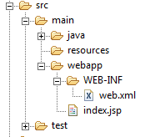

Add java source

Add servlet entry in web.xml

Add servlet dependency

<dependency>

<groupId>javax.servlet</groupId>

<artifactId>servlet-api</artifactId>

<version>2.5</version>

</dependency>

If needed add compiler plugin

<plugin>

<groupId>org.apache.maven.plugins</groupId>

<artifactId>maven-compiler-plugin</artifactId>

<version>3.1</version>

<configuration>

<source>1.6</source>

<target>1.6</target>

</configuration>

</plugin>

To deploy war on tomcat add below plugin

<plugin>

<groupId>org.codehaus.mojo</groupId>

<artifactId>tomcat-maven-plugin</artifactId>

<configuration>

<url>http://localhost:8080/manager/html</url>

<server>myserver</server>

</configuration>

</plugin>

Configure a Run as…

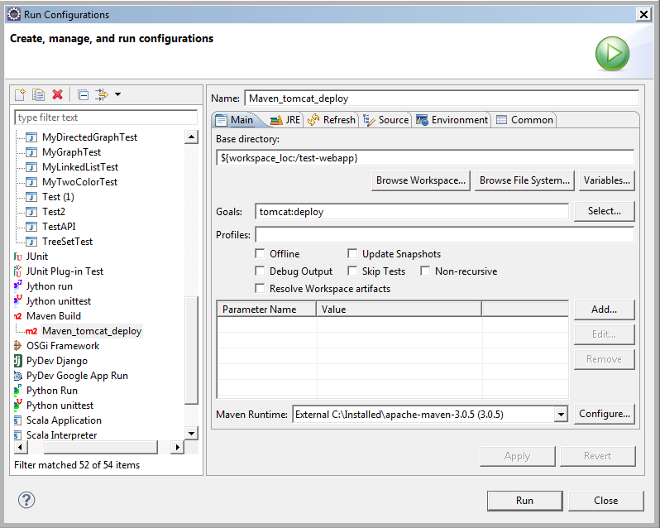

Use Run as..

1. Maven clean
2. Run Above config

Example: test-wepapp

Another method:

Step1: Create maven project by archetype as in previous method

Step2:

Either run below command for the project

mvn eclipse:eclipse -Dwtpversion=2.0

Or create External tool config

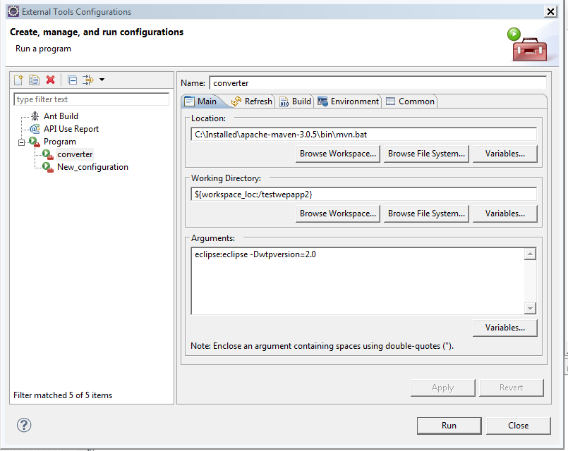

This will make project as Dynamic web project and can be run directly on Tomcat.

Example: testwepapp2